

Intellectual Property Alert:

First PTAB Decision Reversing Examiner

Under New Subject Matter Eligibility Guidance

By Craig W. Kronenthal and Aseet Patel

February 2, 2019 – The Patent Trial and Appeal Board (PTAB), in an *ex parte* appeal (Appeal No. 2017-002898), reversed the examiner’s § 101 rejection based on the USPTO’s new January 2019 subject matter eligibility guidance.

On November 2, 2011, Microsoft filed a U.S. patent application entitled “Extensibility Model For Usage Analytics Used With A System.” As explained in the appeal brief, the application describes methods and systems for configuring usage events to collect usage information and integrating the usage information into a system to provide, for example, a search service that provides search results based on the collected usage information.

During prosecution, the applicant overcame rejections under 35 U.S.C. §§ 101, 102, and 103, and a notice of allowance was issued on April 7, 2014. Then, following the Supreme Court’s *Alice Corp. Pty. Ltd. v. CLS Bank Intern.* decision on June 19, 2014, the examiner issued a non-final Office Action withdrawing the allowance on July 30, 2014. The Office Action included only a new § 101 rejection alleging that the claims were directed to an abstract idea under *Alice*. After several additional amendments and office actions, the applicant filed a notice of appeal, on May 17, 2016, appealing the § 101 rejection as to all claims.

Representative claim 1 recites:

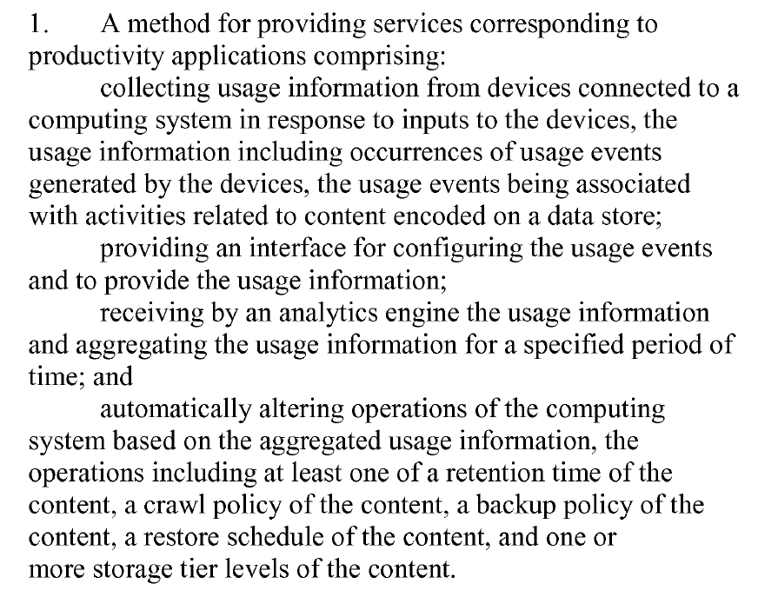

In the Examiner’s Answer to appellant’s appeal brief, the examiner asserted that “[t]he claims are directed towards a method for collecting usage information which includes an abstract idea” and “[t]he claims do not include limitations that are ‘significantly more’ than the abstract idea.” The PTAB disagreed.

On January 22, 2019, the PTAB issued its Decision on Appeal overturning the examiner’s rejection. The PTAB’s analysis begins with an in-depth look at patent eligibility, including a detailed discussion of the two-part Alice/May framework. The PTAB then, *sua sponte*, turns to the *2019 Revised Patent Subject Matter Eligibility Guidance*. On January 7, 2019, the USPTO published new guidance for applying § 101. Under the new guidance, step 2A of the previous framework has been revised to include two prongs:

* Prong One: evaluate whether a claim recites a judicial exception including identifying specific limitation(s) that are believed to recite an abstract idea and determining whether the identified limitation(s) fall within an enumerated abstract idea grouping
* Prong Two: evaluate whether the claim integrates the judicial exception into a practical application.

The PTAB took note of these new prongs, and in particular, the three abstract idea groupings: (i) mathematical concepts, (ii) certain methods of organizing human activity, and (iii) mental processes. The PTAB then found that “[i]n light of our guidance, because collecting usage information is not a mathematical concept, an identified method of organizing human activity, or a mental process, we conclude ‘collecting usage information’ it [*sic*] is not an abstract idea.” Accordingly, the PTAB reversed the § 101 rejection as to all claims.

This marks the first time that PTAB has reversed a § 101 rejection under the recently issued subject matter eligibility guidance.[1] Whether it also signals a shift in PTAB decisions to come, remains to be seen.

To subscribe or unsubscribe to this Intellectual Property Advisory,

please send a message to Chris Hummel at [chummel@bannerwitcoff.com](mailto:chummel@bannerwitcoff.com).

[](http://www.bannerwitcoff.com/)

www.bannerwitcoff.com

© Copyright 2019 Banner & Witcoff, Ltd. All Rights Reserved. The opinions expressed in this publication are for the purpose of fostering productive discussions of legal issues and do not constitute the rendering of legal counseling or other professional services. No attorney-client relationship is created, nor is there any offer to provide legal services, by the publication and distribution of this edition of IP Alert.

1. See also *ex parte Rockwell*, Appeal No. 2018-004973, Jan. 16, 2019, which predates *ex parte Fanaru* by about one week, but it seems that it was not available in online searches until a later date.