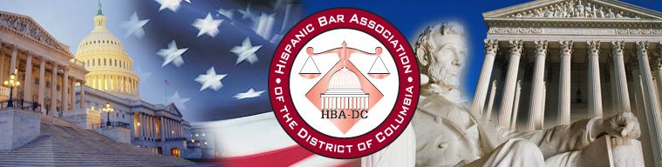

The Hispanic Bar Association of DC
in co-sponsorship with
Crowell & Moring
invite you to a
Summer Associate/Clerk/Intern Reception

Join us in a reception where Summer Associates, Clerks and Interns can
network with Hispanic attorneys in the Washington, DC area. Come explore opportunities and discuss different career paths.

Remarks by Darrell G. Mottley, President-Elect of the D.C. Bar

Wednesday, July 21, 2010
6:30 – 8:30 p.m.

Crowell & Moring
1001 Pennsylvania Avenue, N.W.
Nearest Metro: Federal Triangle and Metro Center

Please RSVP at www.hbadc.org/events
Questions? Contact Marisol Rojo at mentoring@hbadc.org

Become a member of the HBA-DC at http://www.hbadc.org/people/

Please RSVP at www.hbadc.org/events

Questions? Contact Marisol Rojo at mentoring@hbadc.org

Become a member of the HBA-DC at http://www.hbadc.org/people/

